2023 Annual Educational Conference
Program Evaluation Form

Your input and comments are valuable to NERGG as we plan future conferences. Please be sure to evaluate each of our 2023 presentations and speakers. You can go to :

https://unh.az1.qualtrics.com/jfe/form/SV_3Xn8lICQTzJtuaG

OR

Scan this QR code to go to the evaluation form

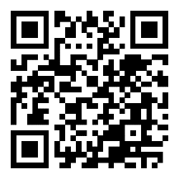

OR

Ask for a paper evaluation form at the registration table

Thank you for your feedback!

